Supplier Admin Area
Supplier Admin Area 1
What is the Supplier Admin Page 1
Navigating to the Supplier Admin Page 1
Company Details Page 2
Audio Eligibility 4
TV Eligibility 7
User Administration 8
Leadership Survey 9

What is the Supplier Admin Page

The Supplier Admin page allows a production company to edit their company details and eligibility as well as submit their leadership survey to the BBC.

In the future, production companies will also be able to maintain their own users and permissions from this page.

A production company can have multiple Admin users, this has initially been assigned to the key contacts for the production company.

Navigating to the Supplier Admin Page

Once the admin user has logged into PiCoS, they will be taken to the main dashboard. From here, you will need to hover over ‘Good Afternoon ‘name’’ in the top right corner, this will display two options – Supplier Admin and Log out.

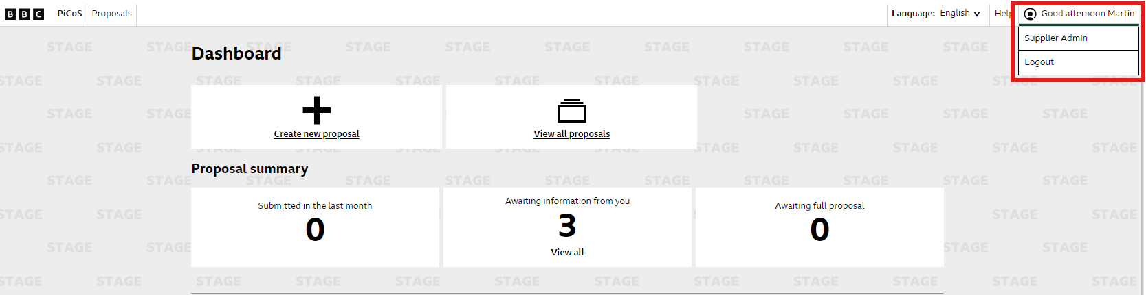

Click on ‘Supplier Admin’

Now that you are in the Supplier Admin page you will see a list of the following options…
- Company Details
- Audio Eligibility
- TV Eligibility
- User Administration
- Leadership Survey

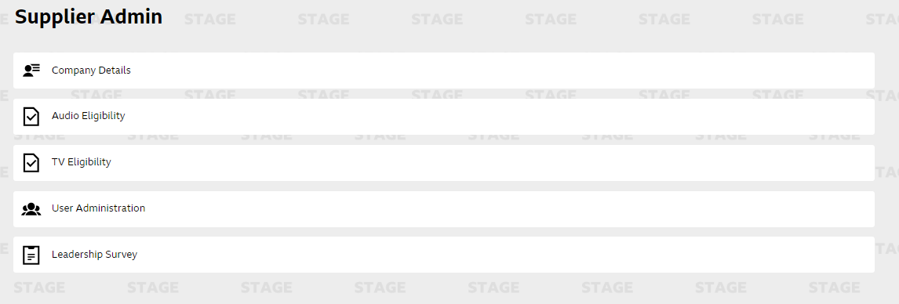

Company Details Page
In the company Details tab, you can edit the following information…
- Company Details
- Additional company Details
- Company Profile
- Key Contacts

You can also sign the Declaration and Terms and Conditions.

On each element, there is an ‘Edit Section’ button on the top right of the section.

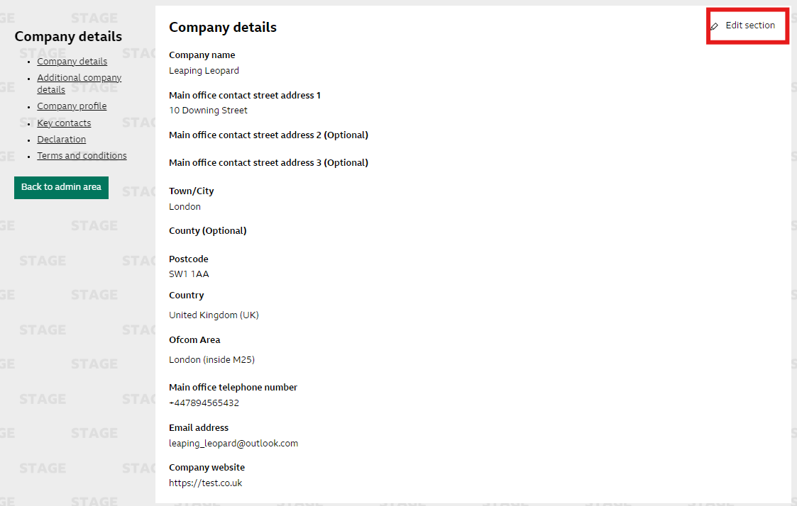

Click on ‘Edit Section’ to start editing. You will see that the section becomes editable and you can amend the required data. When completed the required changes, click ‘Done’ in the top right corner of the section.
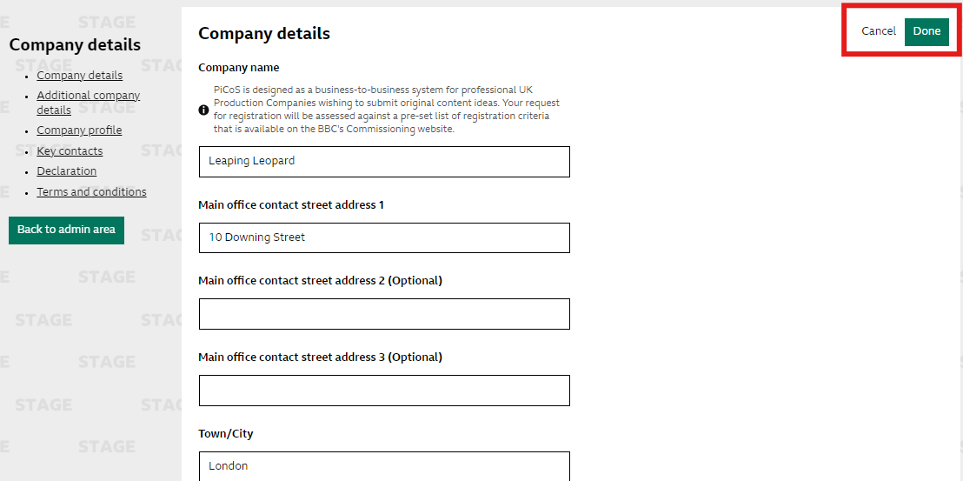

NB: The ‘Main office telephone number’ must begin with the prefix “+44” before the rest of your contact number

Once you are finished editing the sections in the ‘Company Details’ area, you can go back to the main Supplier Admin area by clicking on the green ‘Back to admin area’ button on the left-hand side of the page.

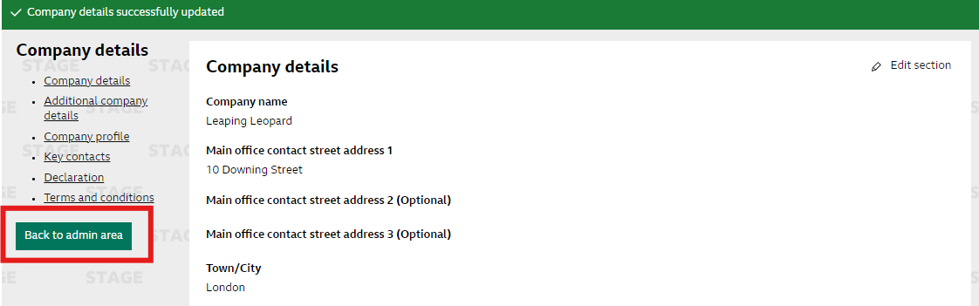

Audio Eligibility
In the Audio Eligibility Criteria page, you can update your companies’ Audio eligibility. You can view your current data and update this when your information has changed, for example your Policy links or change the answer to questions should you need to.

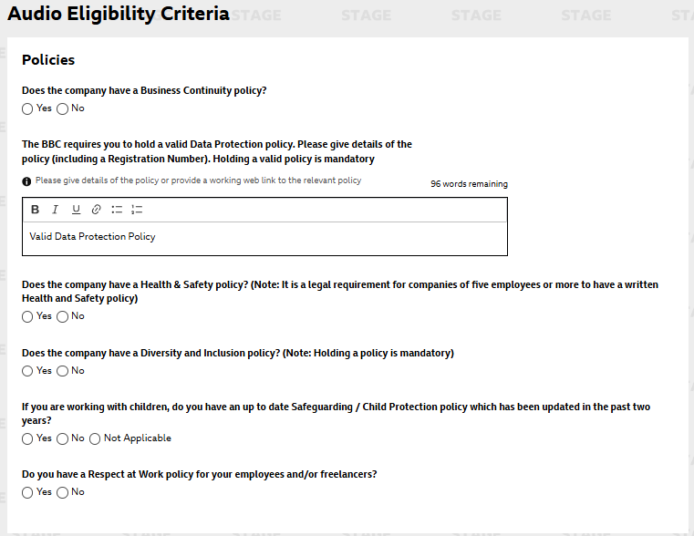

On this Page, you can also document any bankruptcy and insolvency / County court judgements.

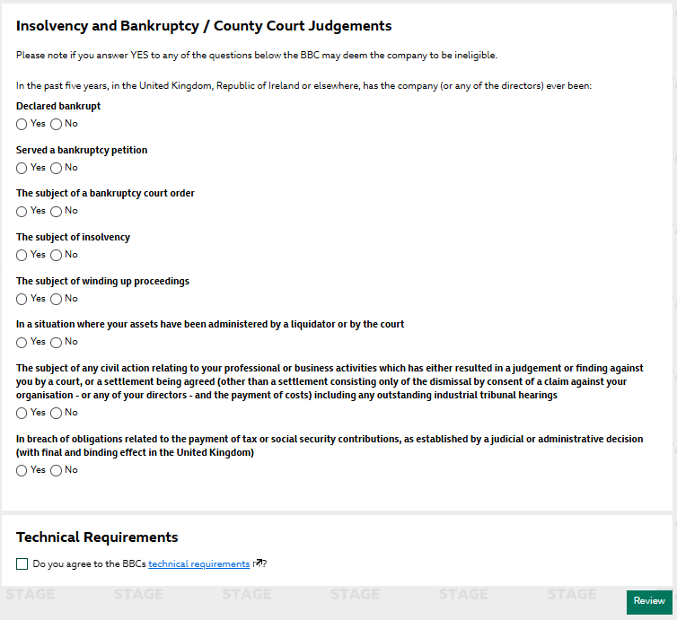

Once you have completed the above form, you can agree to the BBC’s Technical Requirements and then review your document by clicking on the ‘Review’ button in the bottom right-hand corner.

When you are in the review process, you can edit any of the sections previously amended before proceeding to ‘Submit’ the document. You submit the document by clicking on ‘Submit’ in the bottom right corner of the page.
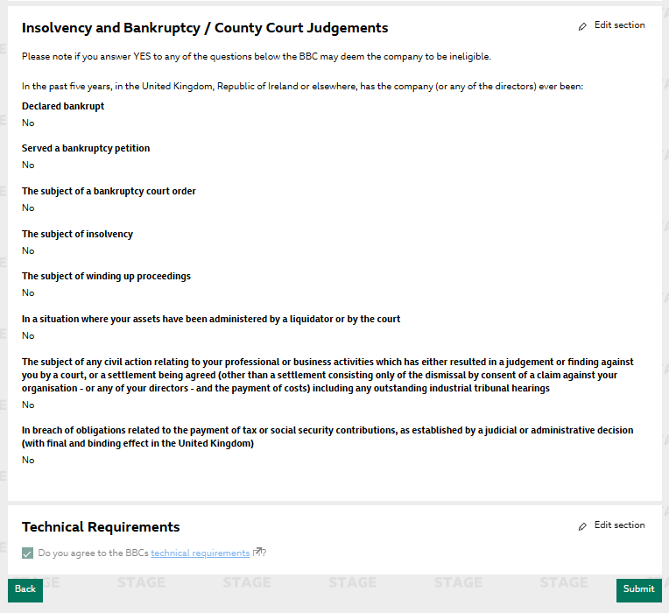

You will then receive the below pop up to show you have successfully submitted your updated eligibility document, these changes will then be reviewed by the Radio Commissioning team.

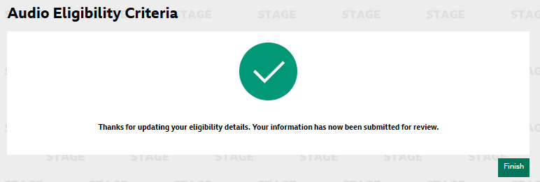

TV Eligibility
In the Tv Eligibility Criteria page, you can update your companies’ eligibility. You will have the option to confirm whether you have had a recent BBC Commission, as well as log if you have had any other recent commissions with other broadcasters.

There are text fields where you can explain in more detail these commissions.

Once you have made the changes required, click on the ‘Review’ button at the bottom right of the page. This will take you to the review page where you can check the inputted information before submitting.

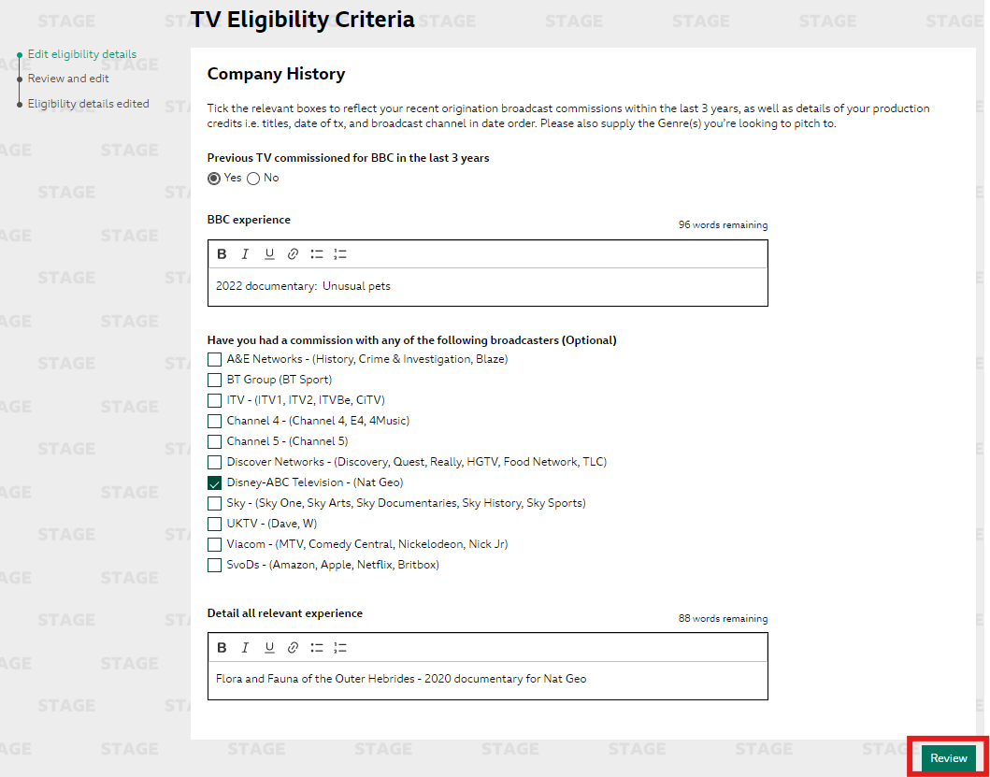

Once in the review page, you can either submit your form onto the BBC for review, or if you need to make additional changes, you can click on the ‘Edit Section’ at the top right of the page.
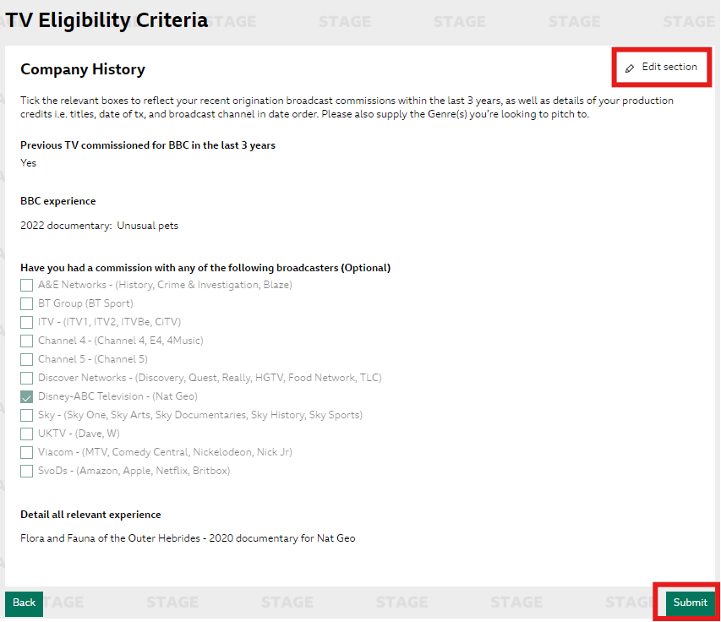

Once you have submitted your eligibility, a pop up will appear informing you that this data has been saved and submitted for review. You can then click ‘Finish’ at the bottom of the of the page. This will take you back the main Supplier Admin area.

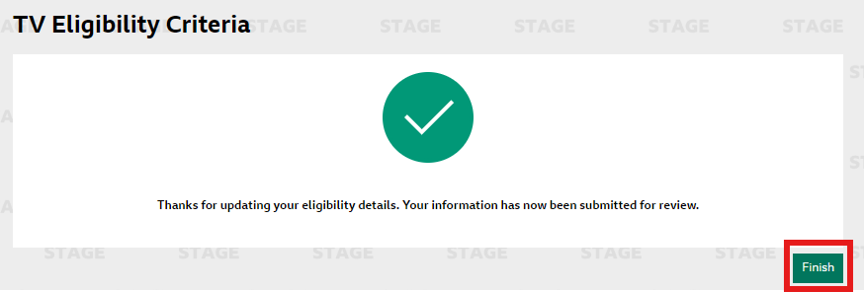

User Administration
The User Administration area is currently still under development, however, what you will be able to see if a full list of all users that have access to your production company

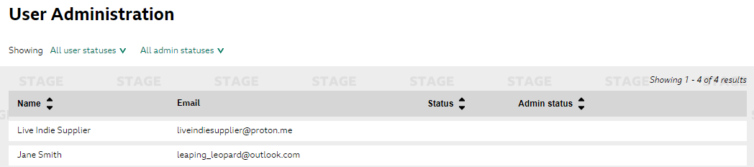

Once developed, you will be able to manage these users access, change their status and set up new users.

Leadership Survey
Click into the Leadership Survey to start completing your form. Once in the form you will notice that your Company Name has been pre-populated.

Enter your details and the area in which you would like pitch to.

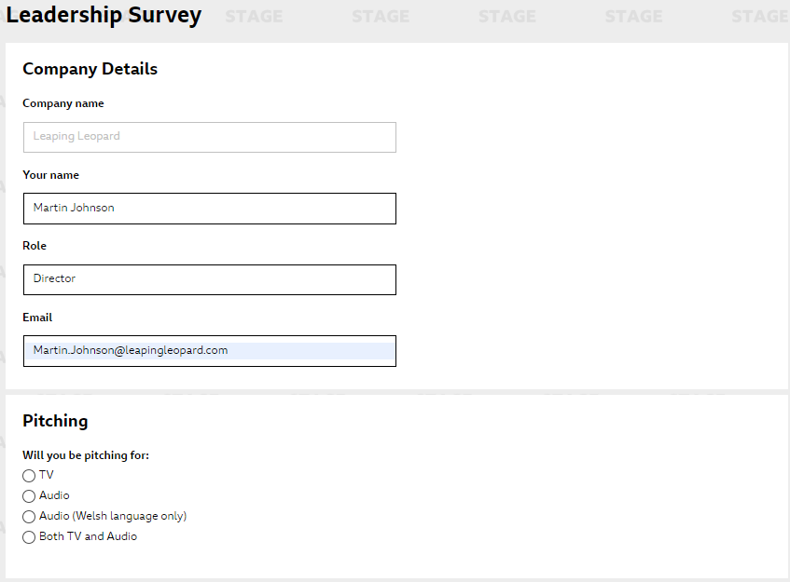

Once you select the area in which you will be pitching to, another set of questions will appear beneath. These questions all require a number field added (i.e there is 1 managing director) Once you have inputted this information, you can click ‘Submit’ at the bottom of the page.

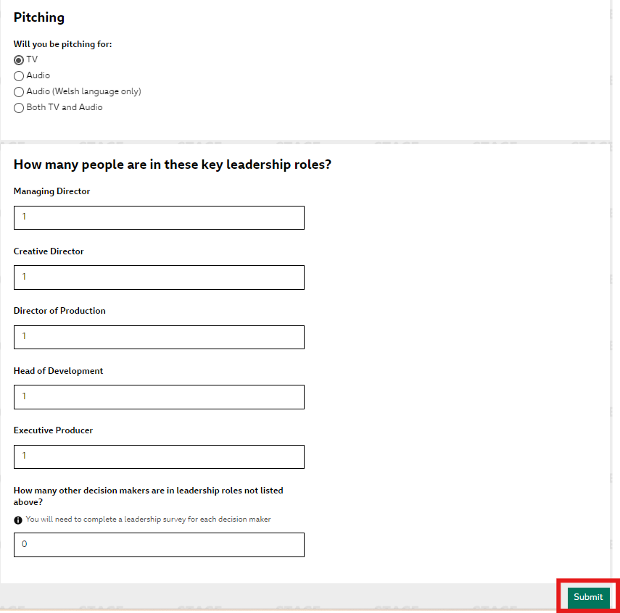

Once you have submitted the above information, you will then need to fill in a form for each role. All areas are mandatory and will need to be completed, you do have the ‘Prefer Not To Say’ option if you would not wish to submit specific information. Please see an example of the form below…
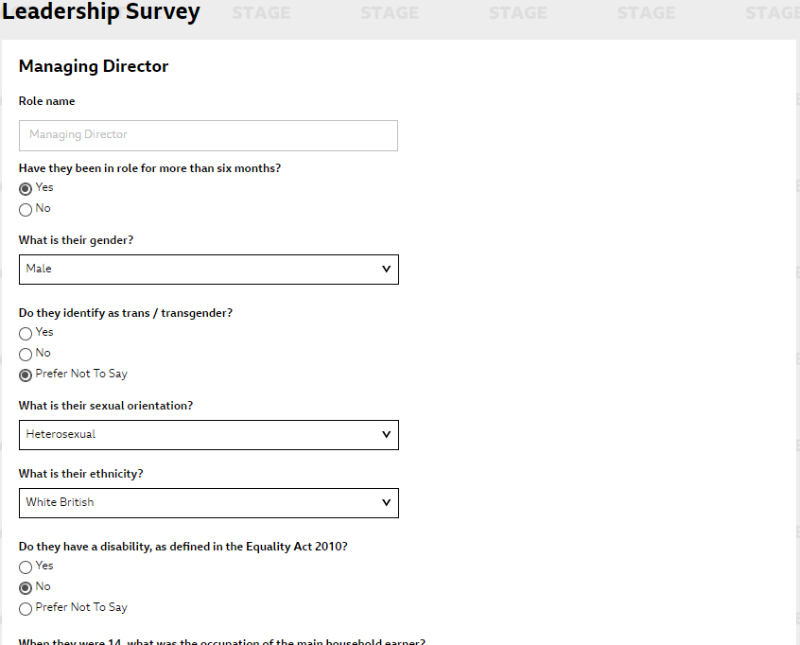
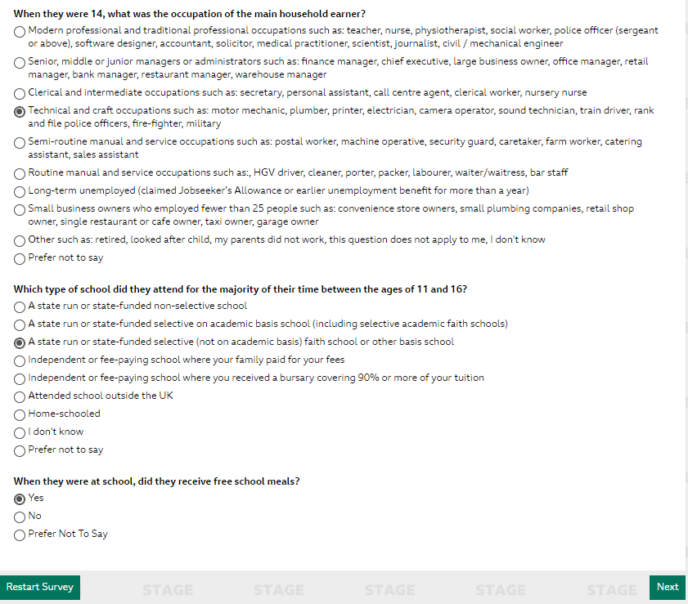

Once completed you can click on ‘Next’ Button at the bottom right-hand side of the page to proceed to the next role. The same form is to be filled in for each of the roles.

Once this has been completed for each of the roles, a pop up will appear to confirm you have submitted your Leadership Survey. (see image below)

