

Proteus: Presentation Details

Document History
Version | Date | Author | Comment
0.1 | 31/12/2019 | Lucy Walters | Created
0.2 | 12/03/2019 | Lucy Walters | Edits and contributions from Deana Page.
0.3 | 10/08/2023 | Shiromi Ramanayake | Edits and contributions from Christine Howard, Deana Page and Shiromi Ramanayake.
0.4 | 31/10/2023 | Shiromi Ramanayake | Edits and contributions from Christine Howard, Deana Page and Shiromi Ramanayake.
0.5 | 24/11/2023 | Shiromi Ramanayake | Edits and contributions from Christine Howard, Deana Page and Shiromi Ramanayake.

Contents
Introduction 2
Finding the Programme 3
Completing the Presentation Details Form 3
Primary Contact 4
LUFs Indicator 4
Technical & Presentation Notes 5
Opening/Closing Announcements and Parts 5
Adding Parts 5
Closing Announcement 6
Pronunciation Details 7
Save 7
Complete 8
Network Approval 8
Repeat Transmissions 9
Programmes without Transmissions (Template) 9

Introduction
The Presentation Details form captures information required by the continuity announcers and presentation areas at the transmitting network.
Presentation Details need to be completed before your programme is transmitted. They also need to be completed per transmission. There is further information about how to copy presentation details from one transmission to another on page 9 of this guide.

Finding the Programme
To find your programme, click ‘Programme/Transmission Search’ and enter the title and date of your transmission into both the ‘From’ and ‘To’ fields.
Click ‘Pres Details’ link related to the relevant programme:

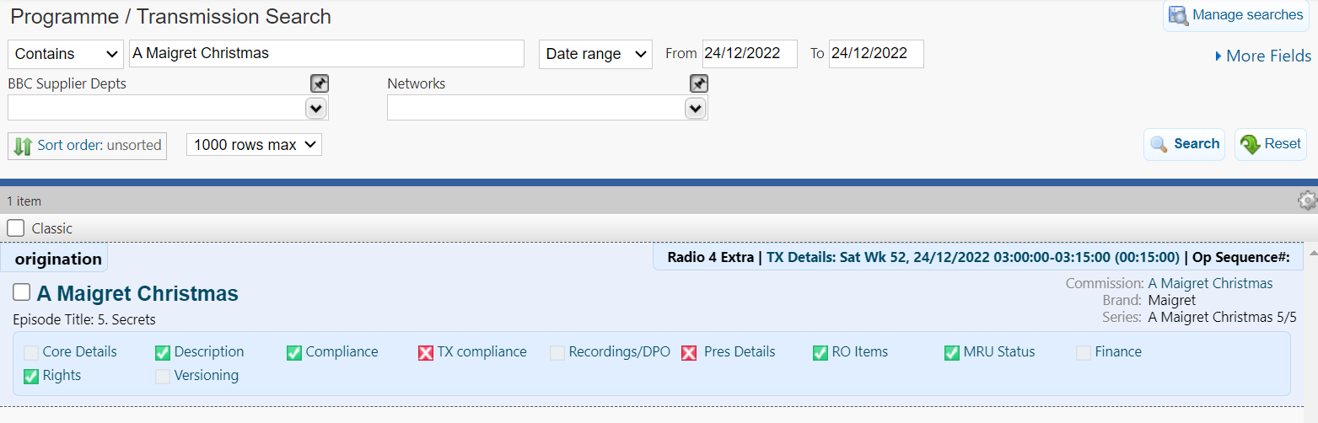

Completing the Presentation Details Form
Some of the fields are pre-populated. This information is pulled through from other parts of Proteus and can be edited by the relevant network on the appropriate page.
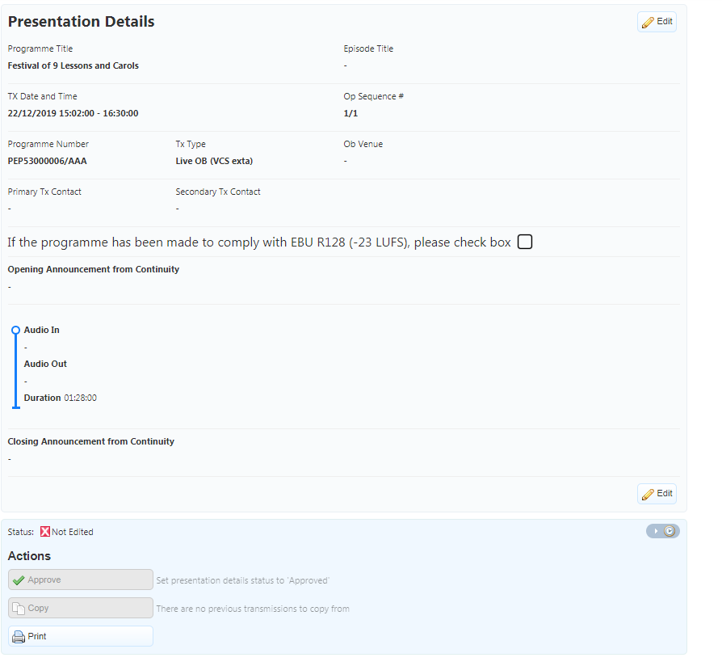
Click ‘Edit’ to add information to the form:

The screen will now be active for you to edit:
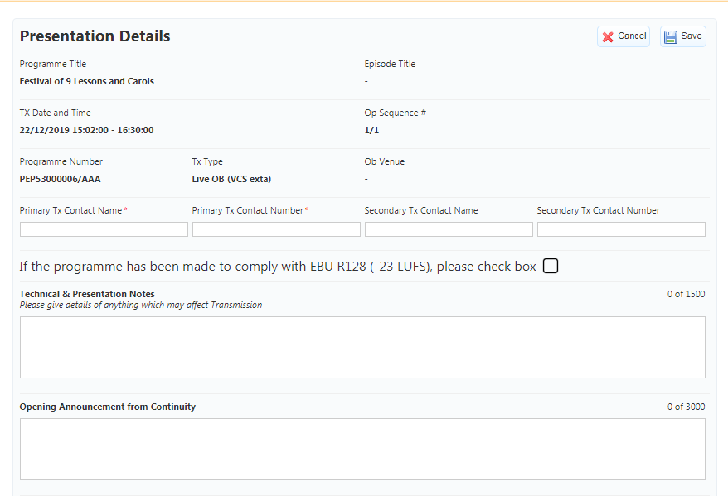

Primary Contact
Enter the primary contact details. This is the contact information for the time of transmission. These are mandatory fields.
You may choose to enter a secondary contact, although this is not mandatory.
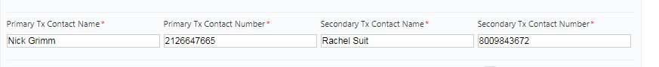

LUFs Indicator
If your programme meets the relevant loudness criteria, tick the check box.
If you do not tick the box, Proteus will prompt you to double check this before you confirm all the information in the form is complete.
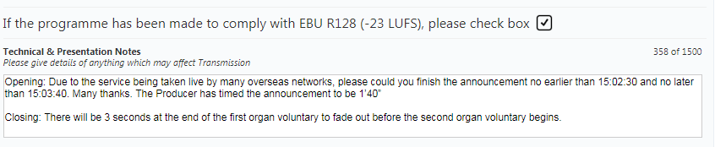

Technical & Presentation Notes
Use this field to flag to the continuity announcer information such as:
Unusually long silences, the deliberate use of distortion, poor quality archive material and the use of either Big Ben or the GTS (pips).
The field should also be used to provide instructions to the announcer such as whether announcements need to start or end at a particular time or should be read over music.

If no information is entered, this field will not be visible after you click ‘Save’.

Opening/Closing Announcements and Parts
Please note that opening and closing announcements are not obligatory.
Enter the opening announcement which you want the continuity announcer to read:
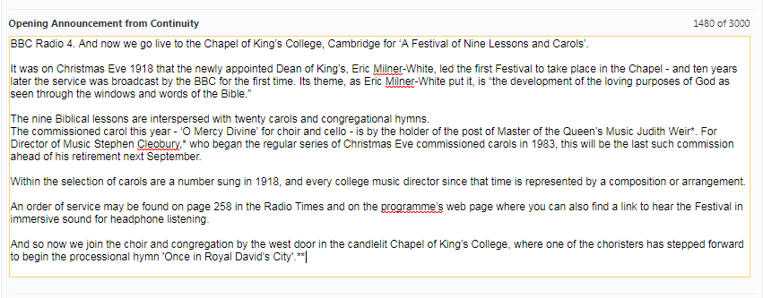

Adding Parts
Your programme may be made up of one or more audio parts.
The relevant network will notify you if your programme should be delivered in multiple parts.
Where your programme is only one part, enter the ‘Audio In’ and ‘Audio Out’ information. This ensures that the Presentation team is aware of how the audio starts and ends, including references to any music, applause, fx, etc which start or end the programme. It is essential that these fields briefly but accurately reflect the delivered audio.
The EOS (end of speech) field is used to indicate the timecode at which the last speech in the programme ends, if it is followed by music, applause or fx. This field only needs to be completed if the programme does not end with speech.
The ‘Duration’ field is currently auto-populated with the programme slot duration, you should overwrite this with the actual total duration of your programme audio.
If there is more than one part, click ‘Add Part’ and enter the details. 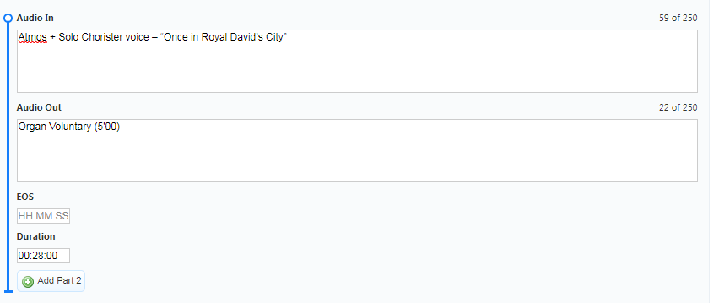
You can also enter a linking announcement if desired.
Click ‘Remove Part’ if you create a part in error:
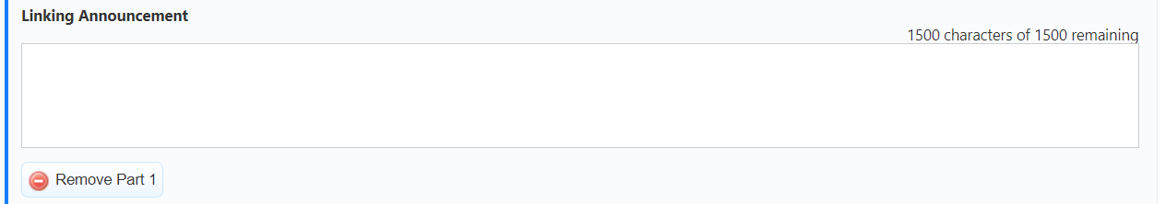

Closing Announcement
Once you have added the programme parts, you can add your closing announcement:
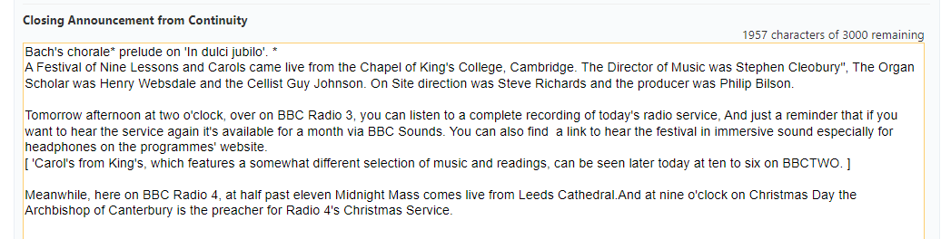

Pronunciation Details
It is essential for the continuity announcer to have a clear indication of syllable sounds and stresses of certain words. For example names of actors or musicians, or foreign language words, with which they may not necessarily be familiar.
Users can copy and paste the modified spellings of words supplied by the BBC Pronunciation Unit (pronunciation@bbc.co.uk) into the ‘Pronunciation Field’:
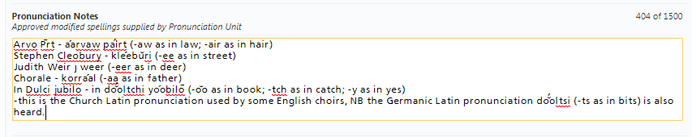
If no information is entered, this field will not be visible once you have saved the form.

Save
After entering the information click ‘Save’: 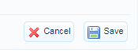
A message will display confirming that the details have been saved.
Save regularly if you are entering lots of information so that you avoid losing any work if your network connection is interrupted.
This will also update the ‘Pres Details Status’ to ‘Edited’:
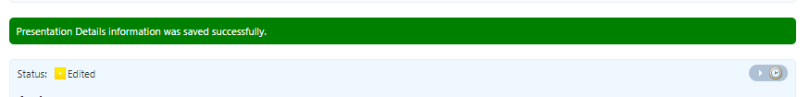

You can return and edit until you are happy that all the information has been entered.
If you click ‘Cancel’ at any stage, the information you have entered will not be saved.

Complete
Once all the information has been entered, and you are happy that it is accurate and ready for broadcast, click the ‘Complete’ button:
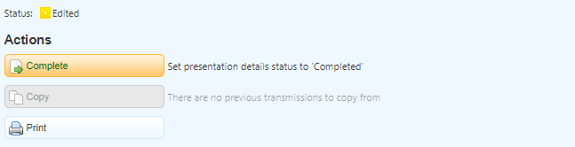

This will update the status of the presentation details to ‘Completed’:

This will trigger an automated email which is sent to the relevant network presentation area.
It is possible to edit if you need to change anything or add missing information. You will need to click ‘Complete’ again, and this will trigger another automated email. For network clarity, it is advisable to avoid editing and resubmitting presentation details too often.

Network Approval
The network can now approve the ‘Presentation Details’ which will update the status to ‘Approved’.
TIP: The ‘Presentation Details’ can be edited after approval, but will need to be completed again so that the Network is alerted to the update and can reapprove the form after editing is complete.

Repeat Transmissions
If you are entering information for a repeat transmission on the same network, you have the option to copy across all the information (e.g. opening/closing announcements) from the most recent TX.
Scroll to the bottom of the form of the new transmission and click ‘Copy’. You can then edit the information if necessary before saving and completing the form.
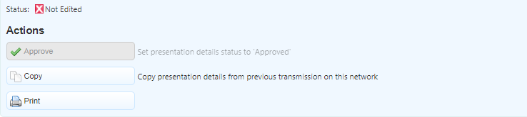
If the repeat is on another network, the opening and closing announcements and other transmission level information will need to be manually copied.
If the repeat is a version, the opening and closing announcements and other transmission level information will also need to be manually copied.
The ‘Parts’ and ‘LUFs’ tick box will already be populated for any repeat transmission on any network.

Programmes without Transmissions (Template)
If your programme does not have a transmission date yet, click the Pres Details link and you can enter information into the template.
Fill in the information as normal. Click the ‘Complete’ button at the bottom of the form. This will trigger an automated email to the relevant network presentation area for approval.
If you need to edit again, you can do so but you will need to click the complete button again.
Once the network has entered a Tx Date, the template will disappear and Proteus will automatically copy the information and status to the presentation details form related to the transmission. If repeat transmissions are also scheduled, the information can be copied as previously described.
For any technical queries, please contact:
E-mail: proteus.support@bbc.co.uk
Telephone: 0303 080 1815
For any editorial queries, please contact the relevant network presentation team.

