Notifications
Contents
Supplier Notifications 2
Summary to Suppliers 2
Supplier notifications in detail. 2
Proposal Submitted 2
Proposal Shortlisted/ Progressed (1 step / open rounds) 3
Proposal Awaiting Full Proposal (2 Step process) 3
Proposal Rejected 4
Proposal Commissioned 5
More Information required 5
Proposal On Hold / Resume from On Hold. 6
Supplier Withdraws proposal 6

Supplier Notifications

Summary to Suppliers

Below is a summary of the notifications that are sent to Production companies from PiCoS.

Notification Trigger | Auto (Always send) | Optional (commissioner can choose to not send) | Commissioner can edit the recipient
Proposal Submitted | Yes | N/A | No
Proposal Shortlisted / Progressed (1 step) | No | Yes | No
Proposal Awaiting full proposal (2 Steps) | No | Yes | No
Proposal Rejected | No | Yes | No
Proposal Commissioned | No | Yes | No
More Information required | Yes | No | No
Proposal On Hold | Yes | No | No
Resume from On Hold | Yes | No | No
Supplier Withdraws proposal | Yes | N/A | No

Supplier notifications in detail.

Proposal Submitted
When a supplier submits a proposal an automatic will be sent to then to confirm they have successfully submitted their proposal. This is sent to the person wo created the proposal, who it is assigned to and any additional contacts the supplier has requested to receive notifications.

This email notification will look like the below.

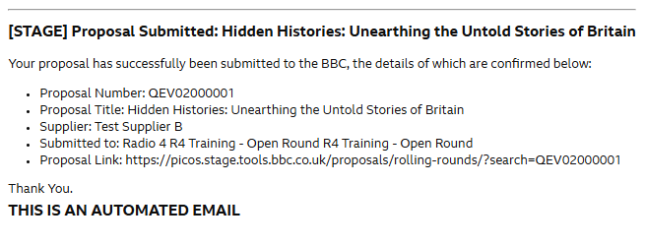

Proposal Shortlisted/ Progressed (1 step / open rounds)
For a proposal that has been submitted into a round where they are required to submit the full proposal up front (i.e. Open Rounds) the supplier will receive a notification when a commissioner Shortlists their proposal.

The Commissioner will be given the below prompt when they shortlist the proposal to ask if they would like to send the supplier a notification.

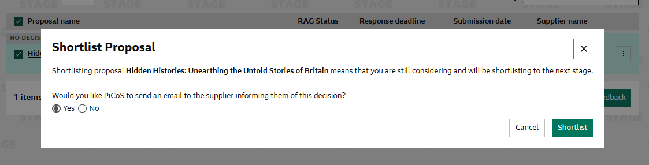

If the commissioner chooses to send the supplier a notification, the supplier will receive the below notification.

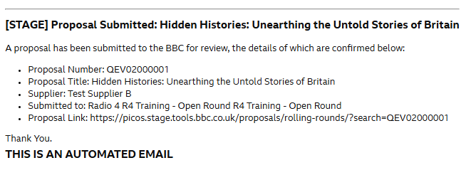

Proposal Awaiting Full Proposal (2 Step process)
A Supplier will receive a Notification when their proposal has been shortlisted / Progressed to the second stage of a two-step round.

At the point in which the commissioner publishes the results of the first stage, they will be given a prompt like below to ask whether they would like to send a notification to the supplier.

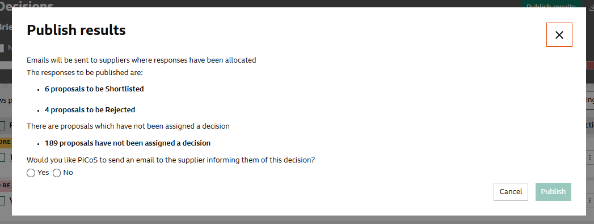

NB: These notifications cannot be toggled on an off per decision, this is a blanket response to all notifications that re due to be sent at this stage.

The Shortlisted notification will look like the below…
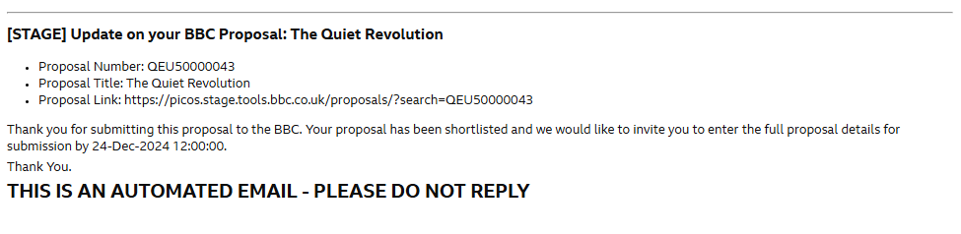

Proposal Rejected
A Supplier will receive a notification either in the initial or final stage of their submission if the commissioner has decided to reject their proposal.

The commissioner can choose to not send this notification to the supplier, they will get the below pop up when they go to reject this.

NB: These notifications cannot be toggled on an off per decision, this is a blanket response to all notifications that re due to be sent at this stage.

The rejected email notification will look like the below…

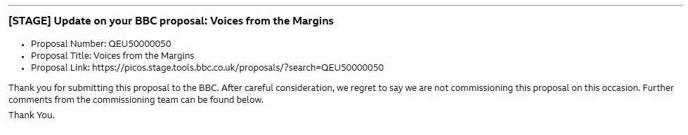

Proposal Commissioned
A Supplier will receive a notification either in the initial or final stage of their submission if the commissioner has decided to commission their proposal.

The commissioner can choose whether they would like to send a notification to the supplier to inform them of this decision.

The notification that the supplier receives will look the below…

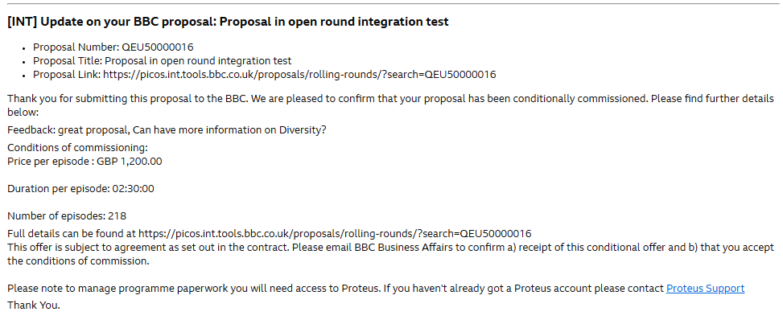

More Information required
When a commissioner requests a Production Company to supply more information on their proposal, they will receive an automated email notification informing them to supply more information. This notification will include the information you have asked them to provide.

This notification cannot be switched off and will always be sent when ‘More Info’ has been asked for.

The notification will look like the below…

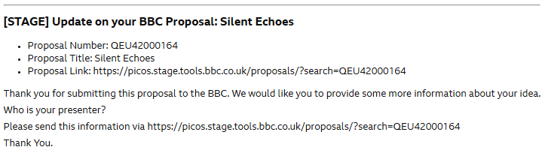

Proposal On Hold / Resume from On Hold.
When the commissioner places a proposal on hold, the supplier will receive the below notification.

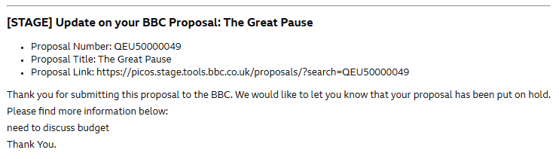

This notification is compulsory and cannot be switched off. When you place a proposal on hold you can give the supplier information as to why this is the case and this will be populated in the email notification, as seen above.

When you resume a proposal, the supplier will receive the below notification informing them you have taken the proposal off ‘On hold’. This notification is compulsory and cannot be switched off by the commissioner.

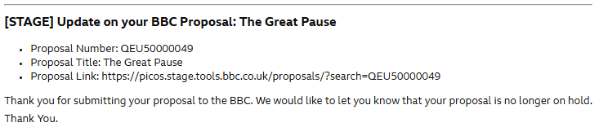

Supplier Withdraws proposal
When a supplier withdraws their proposal from consideration, they will automatically be sent an email from PiCoS confirming their proposal withdrawal. This notification will look like the below.
