NIHD2 – Provisional Information
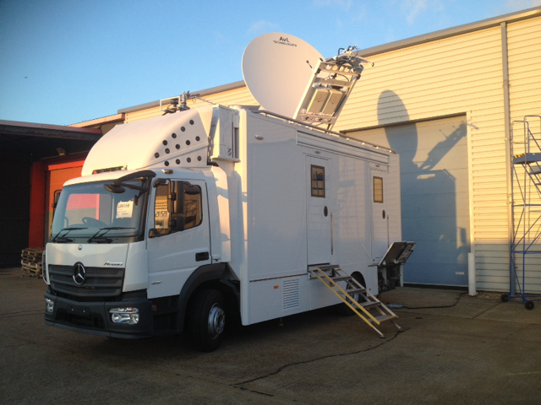
Vision Mixer:
MVS3000A with 32 Primary Inputs 16 Assignable outputs fitted with the optional MKS-6570 DME Board.
ICP-3000, 2 M/E Control Panel 24 Button and the ICP-6511 Menu Panel.
Audio Mixer:
Roland M-480 48 Channel Mixing Console with three Stage box systems
Communications System:
Clear-Com Eclipse HX-Median with 64 ports including IP connectivity.
2 Radio Talk back base stations
Video and Audio Routers:
Evertz Xenon Video Router 128 x 128.
Evertz Xenon Audio Router 196 x 196 including 64 x 64 MADI.
Hardware control panels and BNCS Touch screen control.
Cameras:
5 Sony 1500 R Fibre Cameras in HD.
Provision to support 1 Radio cam with Receive antenna on a 12 meter mast.
EVS:
Supports 1 EVS XT HD 6 channels slomo unit equipped with XFly for transportable drives.
Graphics:
1 VizRT graphics engine on board with operational provision for VizRT Trio unit.
Satellite:
AVL 2.4 M Dish with dual 400 watt HPA’s.
Dual Ateme HD encoders with IP capability.
Dual Ericsson IRD’s .
The unit has the ability to transmit and receive 2 HD signal paths simultaneously.
DSAT and DTT Off air monitoring.
Electrical:
3 Phase 125 Amp connection with Mains Isolation transformer.
230-240 Volt 3 Phase at 50 Amps operation.
Layout:
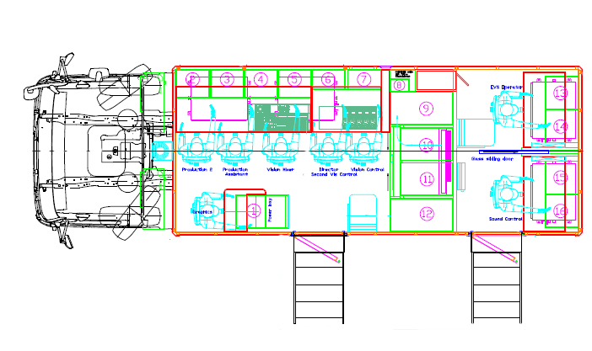
Seating for the following
Main Area | Second Area
2 x Production | Sound Supervisor (1 + Jump Seat)
Director | EVS Operator (1 + Jump Seat)
Vision Mixer
Vision Supervisor
Graphics Operator
Satellite Operator (Jump seat)

